| Preparatio |  |  |  |  | logo1.png |
| --- | --- | --- | --- | --- | --- |

| Course Name | | Zoho Books | |
| --- | --- | --- | --- |
| College Name | | Mangayarkarasi College of Arts and Science for Women Paravai, Madurai - 625002 | |
| College Code | | MKU251 | |
| Skill Offering Id | |  | |
| Project Title | | Preparation And Maintanence of zoho Books for Fashion Haven | |
| Project Submitted To | | Madurai Kamaraj University ( Naan Mudhalvan Scheme(TNSDC)) | |
| Year | | 2023 | |
| Department | | B.COM Computer Application | |
| Semester | | 6 | |
| Group Number | | 28 | |
| Total Members of the Group | | 5 | |
| Group Members Details | | | |
| Name of the Member | University Register. No | | Student NM ID |
| E.Sneka | C1C15408 | | 7BA697B4E24E18C952B42346E717A2F5/NM2023TMID3630 |
| M.Mahalakshmi | C1C15379 | | 4DB51A2CA4BBB6CB657484709C5B35C0 |
| K.Kanchana | C1C15369 | | 472E17792937BAFA7B4481A8F255D9A6 |
| G.Muthuselvi | C1C15383 | | B86C17937D519EDB3C84E75BCFB28E55 |
| A.Deepalakshmi | C1C15356 | | 9C7CB604D5C3AADB18843ED349C78F6E |
| Under the Guidance | | Ms.R.Anu | |
| SPOC | | Ms.P.UMADEVI | |

Preparation and Maintanence of ZOHO Books for Fashion Haven

1. **Introduction.**

*1.1 Overview*

Fashion Haven, an online retail store, leverages Zoho Books to manage their inventory and track sales. They can generate invoices and manage customer payments seamlessly. Zoho Books also enablesThem to reconcile bank transactions and generate financial reports, helping them make informed Decisions about their business..

Fashion Haven is a Private Limited company also registered under GST in Tamil Nadu. Fashion Haven Is a retailor of various lifestyle products in wholesale and retail, it has a wide range of customers (B2B & B2C) all over the state and it procures from various suppliers in the state. It operates at a Gross Profit Margin of 50%.

*1.2 Purpose*

Fashion Haven is a Private Limited company also registered under GST in Tamil Nadu. Fashion Haven is a retailor of various lifestyle products in wholesale and retail, it has a wide range of customers (B2B & B2C) all over the state and it procures from various suppliers in the state. It operates at a Gross Profit Margin of 50%.

1. **Problem Definition and Design Thinking**
   1. Empathy Map

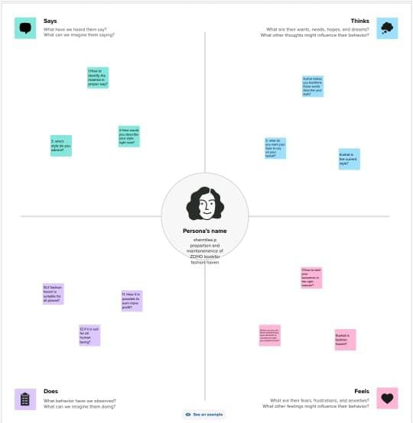

2.2 Ideation and Brainstroming Map

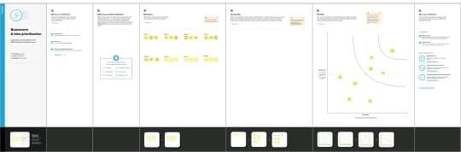

Milestone 1: Set up your account

Activity 1: Sign up for a Zoho Books account and Login

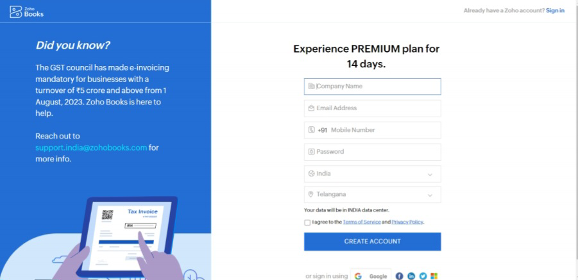

Activity 2: Introduction

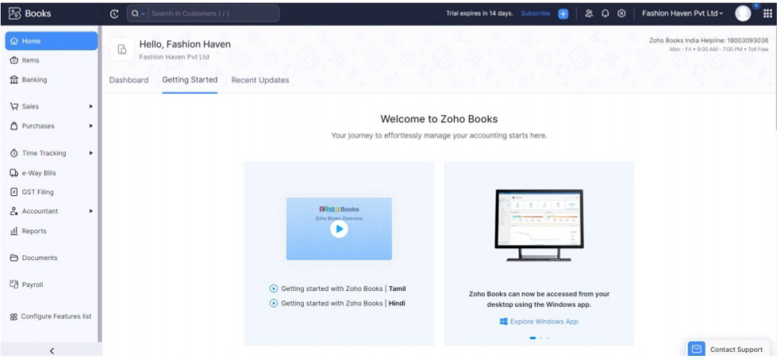

Milestone 2: Products/Items:

Activity 1: Creation

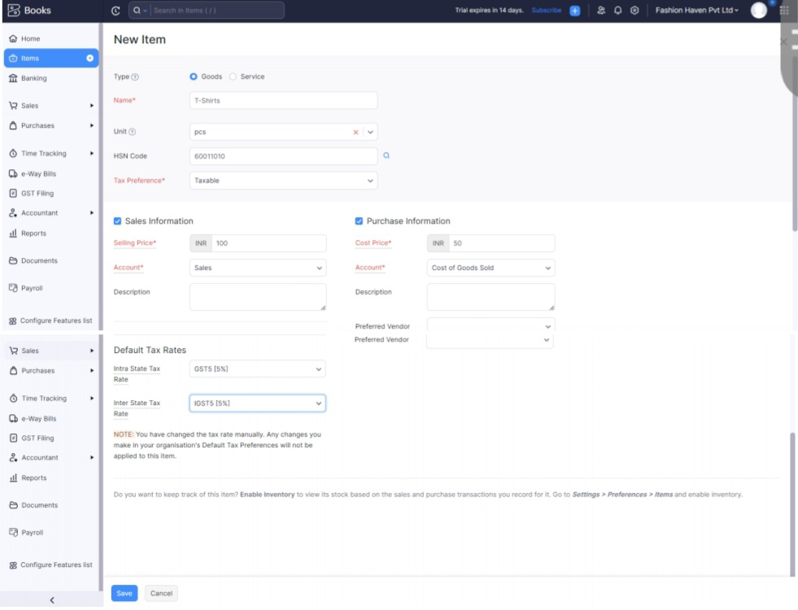

Milestone 3: Vendors

Activity 1: Vendors Creation

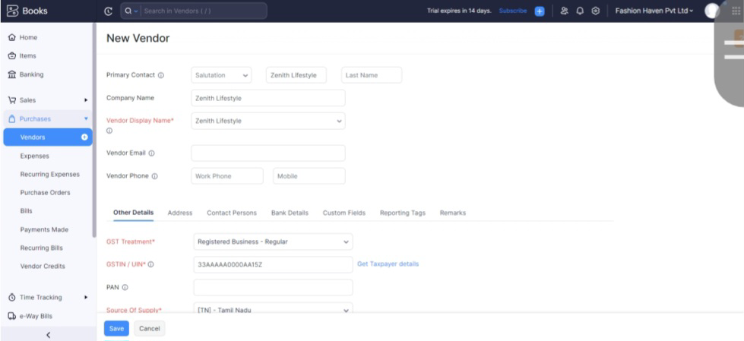

Activity 2: Review of Vendors List

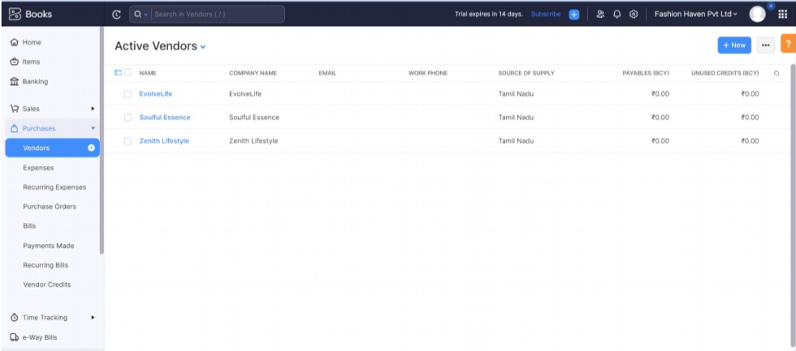

Milestone 4: Purchases

Activity 1: Purchase Order

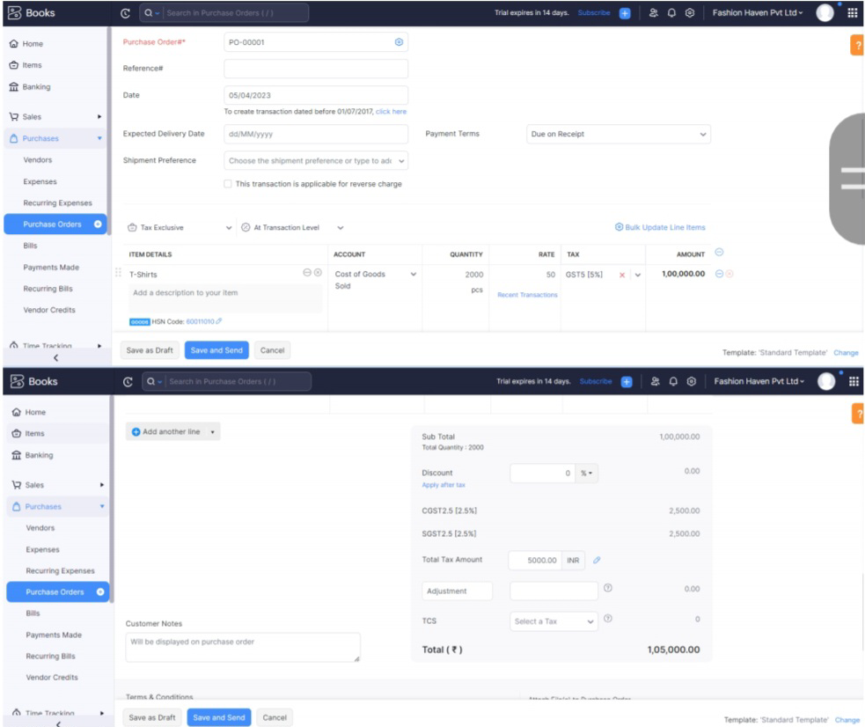

Milestone 5: Customers

Activity 1: Customers Creation:

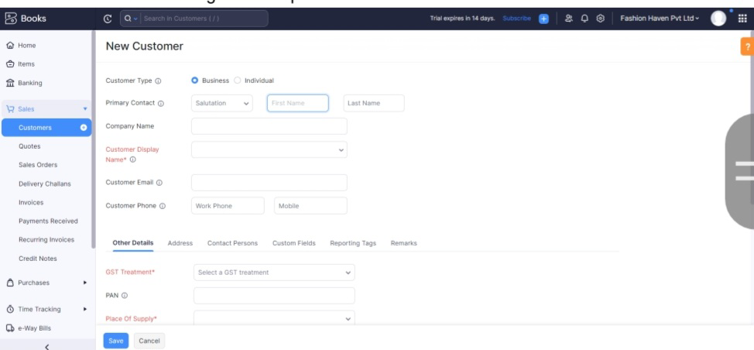

Milestone 6: Sales

Activity 1: Sales Order Creation

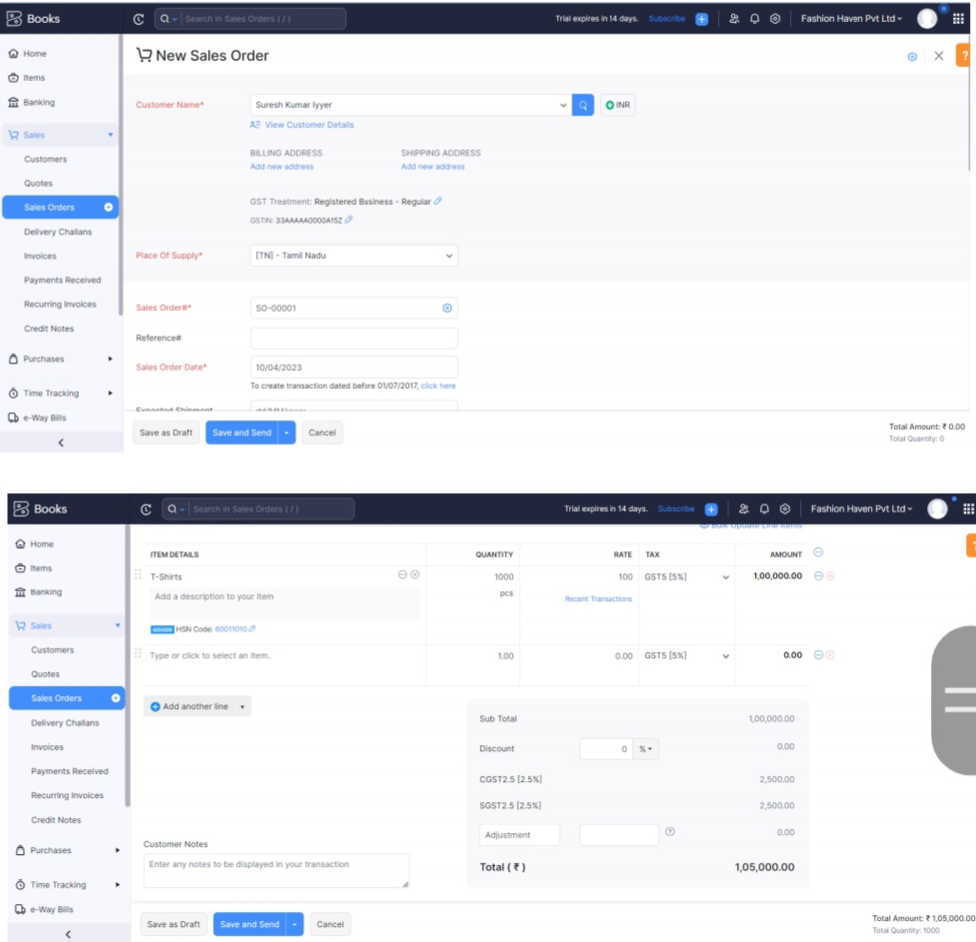

Milestone 7: Bank Account

Activity 1: Adding Bank Account

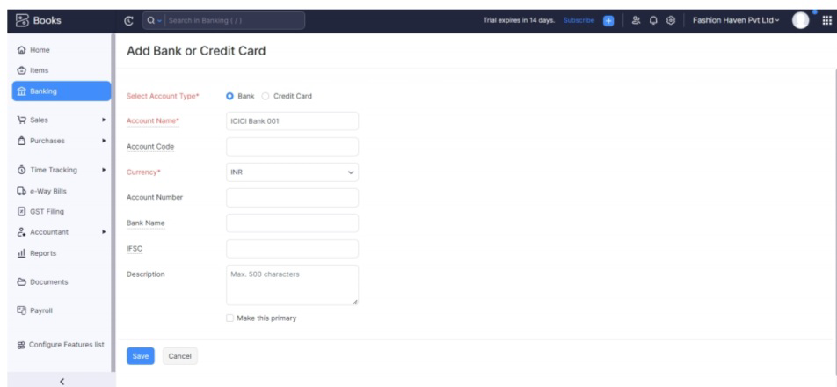

Milestone 8: Accounts & Ledgers

Activity 1: Creation of New Accounts/Ledgers:

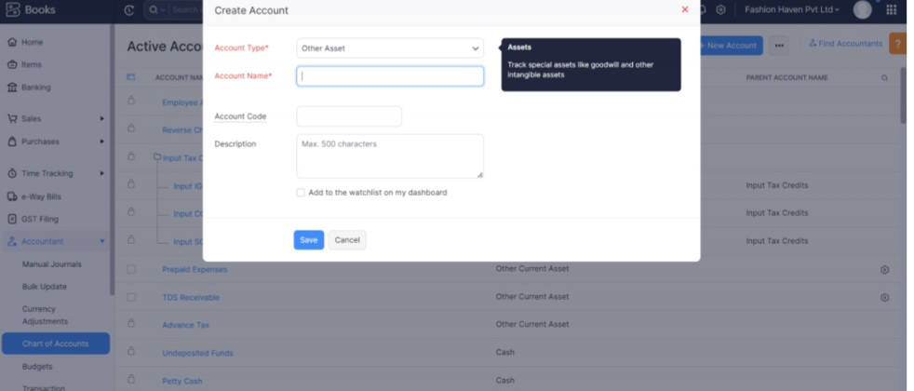

Milestone 9: Journal Entries:

Activity 1: Recording of Journal Entries

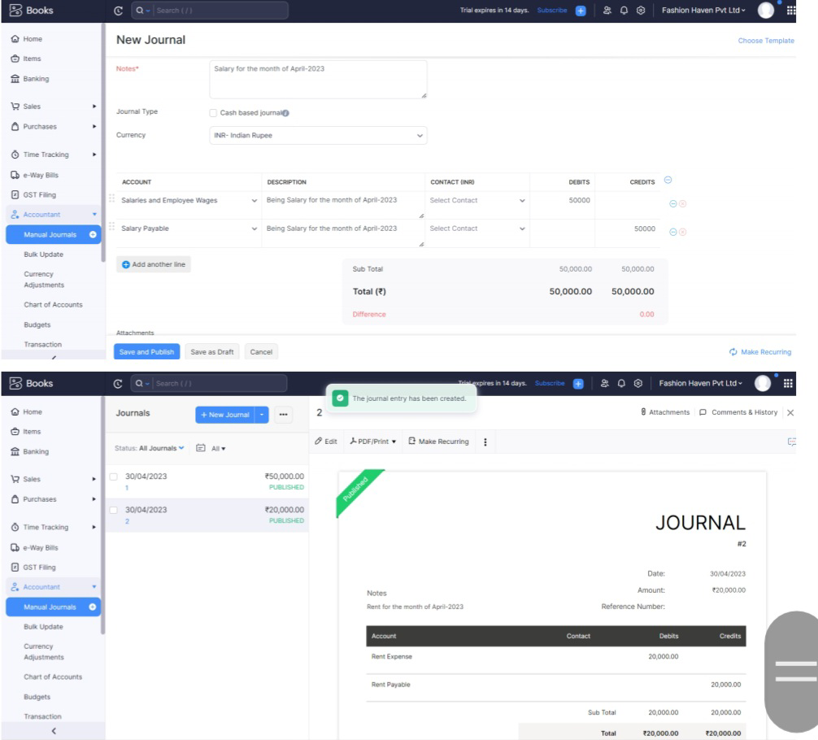

Milestone 10: Expense & Bills

Activity 1: Expense & Bills Entry

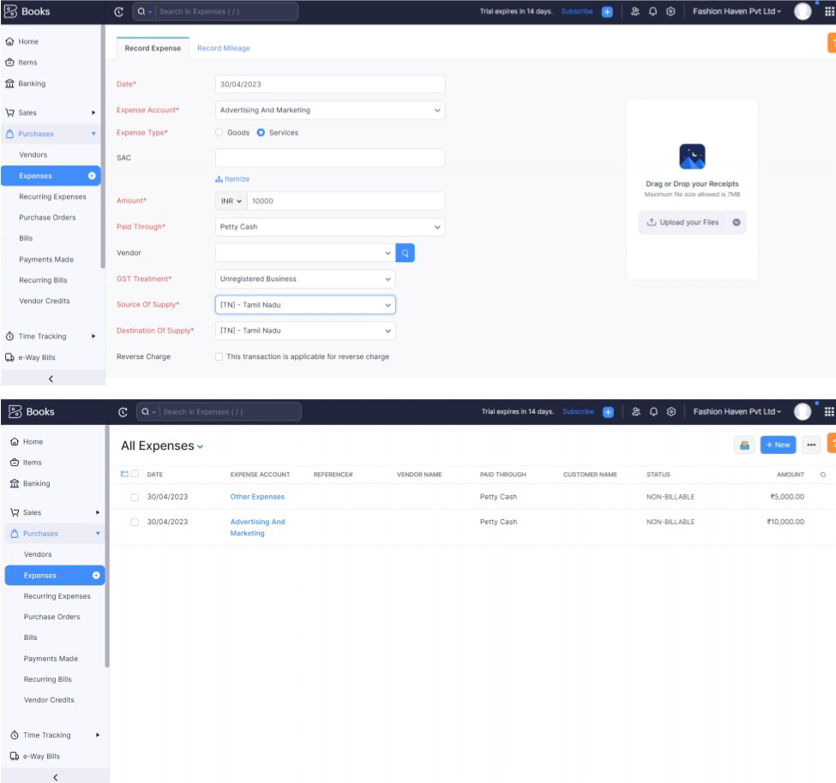

Milestone 11: Bank Entries

Activity 1: Recording of Bank Transactions

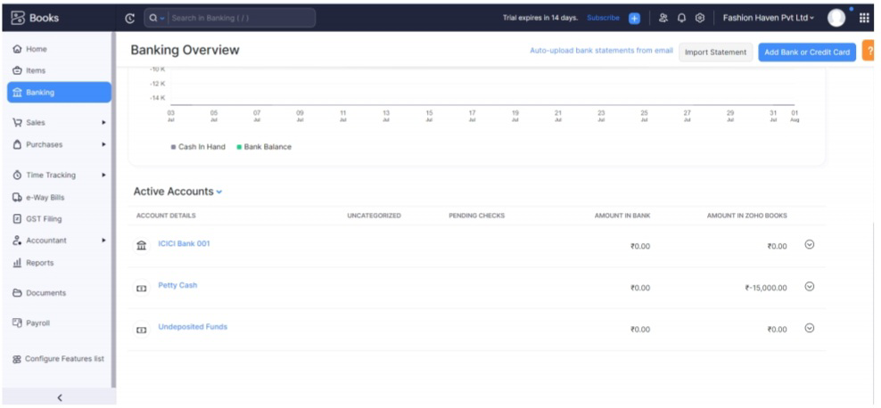

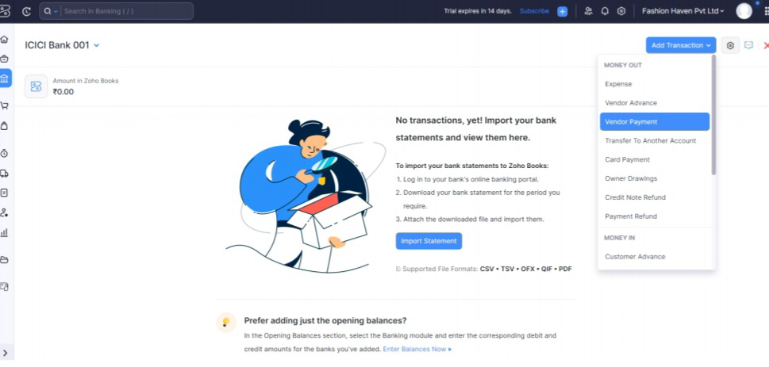

For Customer Payment

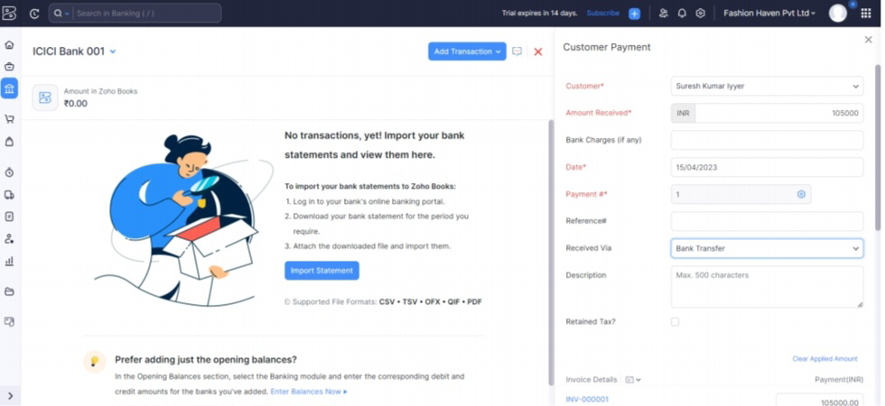

Milestone 12: Financial Reports:

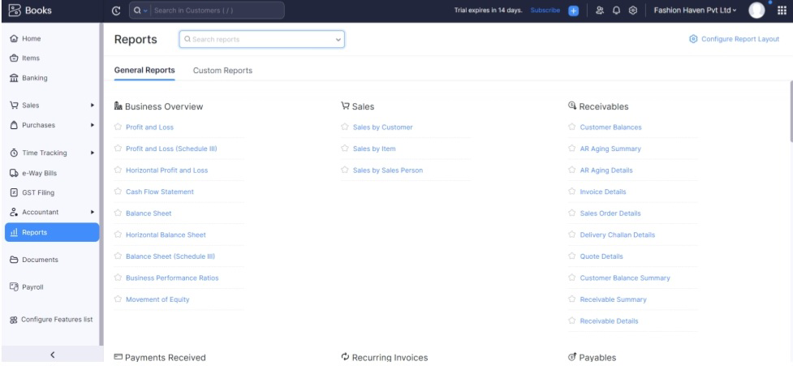

Activity 1: Profit and Loss Account

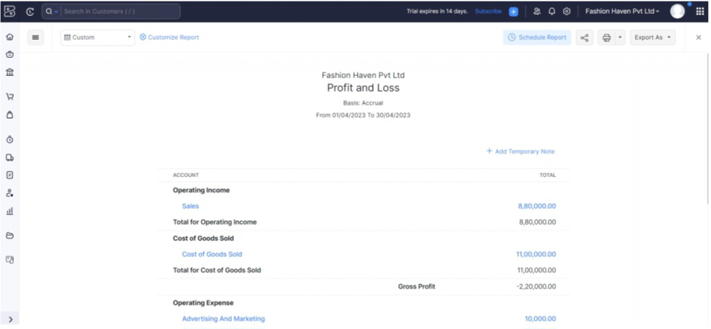

Activity 2: Balance Sheet



Activity 3: GST Reports

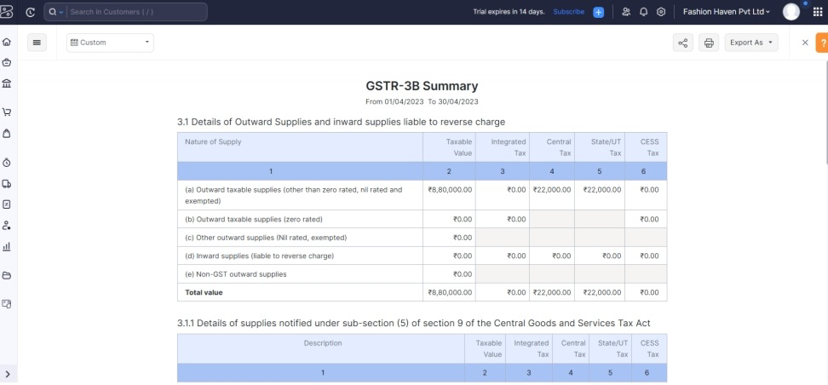

**Conclusion:**

In the cade of fashion haven,, now a day their are very much interested in the fashion Haven due to many reasons. The only way of how to create zoho book who need to open the account in very serious issues.. so that the zoho Books are very useful..